Data Visualization for Bakery sales dataset

No of items, week and weekend scenario with period, key influences, Most sell item…..

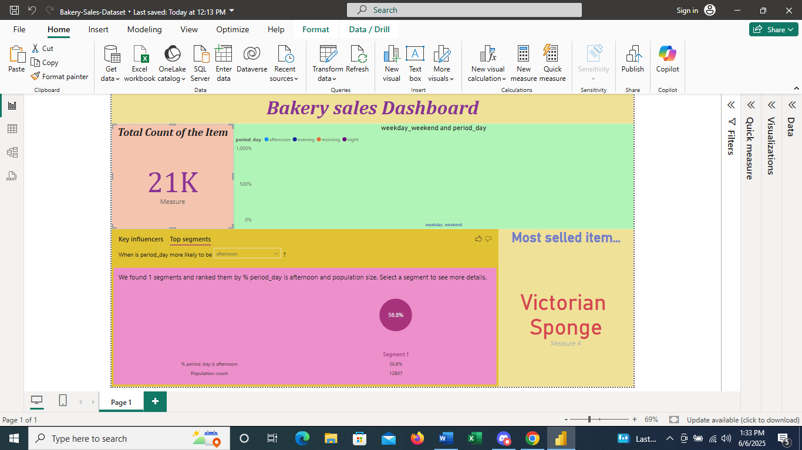

Top segments Data Visualization 